**Structure of this paper**

|  |  |  |  |  |  |  |
| --- | --- | --- | --- | --- | --- | --- |
| **Section** | Number of questions available | Number of questions to be answered | Suggested working time (mins) | Marks available | Percentage of exam | % achieved |
| Section One:  Multiple-choice | **30** | **30** | **40** | **60** | **30** |  |
| Section Two:  Short answer | **5** | **5** | **90** | **100** | **50** |  |
| Section Three:  Extended answerUnit 1 | **2** | **1** | **50** | **40** | **20** |  |
| Unit 2 | **2** | **1** |  |  |  |  |
|  |  |  |  | **Total** | **100** |  |

**Instructions to candidates**

1. The rules for the conduct of WACE examinations are detailed in the *Year 12 Information Handbook 2017*. Sitting this examination implies that you agree to abide by these rules.

2. Answer the questions according to the following instructions.

Section One: Answer **all** questions on the Multiple-choice Answer Sheet provided. For each question, shade the box to indicate your answer. Use only a blue or black pen to shade the boxes. If you make a mistake, place a cross through that square, then shade your new answer. Do not erase or use correction fluid/tape. Marks will not be deducted for incorrect answers. No marks will be given if more than one answer is completed for any question.

Section Two: Write your answers in the spaces provided in this Question/Answer Booklet. Wherever possible, confine your answers to the line spaces provided.

Section Three: Consists of two parts each with two questions. You must answer **one** question from each part. Tick the box next to the question you are answering.

3. You must be careful to confine your responses to the specific questions asked and to follow any instructions that are specific to a particular question.

4. Additional working space pages at the end of this Question/Answer booklet are for planning or continuing an answer. If you use these pages, indicate at the original answer, the page number it is planned/continued on and write the question number being planned/continued on the addition working space page.

**Section One: Multiple-choice 30% (30 Marks)**

This section has **30** questions. Answer **all** questions on the separate Multiple-choice answer sheet provided. For each question, shade the box to indicate your answer. Use only a blue or black pen to shade the boxes. If you make a mistake, place a cross through that square, then shade your new answer. Do not erase or use correction fluid/tape. Marks will not be deducted for incorrect answers. No marks will be given if more than one answer is completed for any question.

Suggested working time: 40 minutes

1. The correct sequence, from the most to the least descriptive, of the taxonomic levels listed below is

(a) family, phylum, class, kingdom, order, species and genus.

(b) species, genus, family, order, class, phylum, kingdom.

(c) kingdom, phylum, order, class, family, genus, species.

(d) phylum, kingdom, order, genus, class, species, family.

2. Members of which kingdom have cell walls and are **all** heterotrophic?

(a) Plantae

(b) Fungi

(c) Protista

(d) Animalia

3. Cell growth and reproduction requires the input of many different elements. The synthesis of new nucleotides during cell division cannot occur in the absence of

(a) calcium

(b) magnesium

(c) nitrogen

(d) sulphur

4. Which definition best describes a living species?

(a) An organism that is alive.

(b) An organism that can mate and produce offspring.

(c) A group of organisms that can mate and produce fertile offspring.

(d) A group of identical organisms that can mate and produce fertile offspring.

5. A group of potentially interbreeding individuals present at the same location is a/an

(a) ecosystem.

(b) community.

(c) niche.

(d) population.

Question 6 refers to the following graph

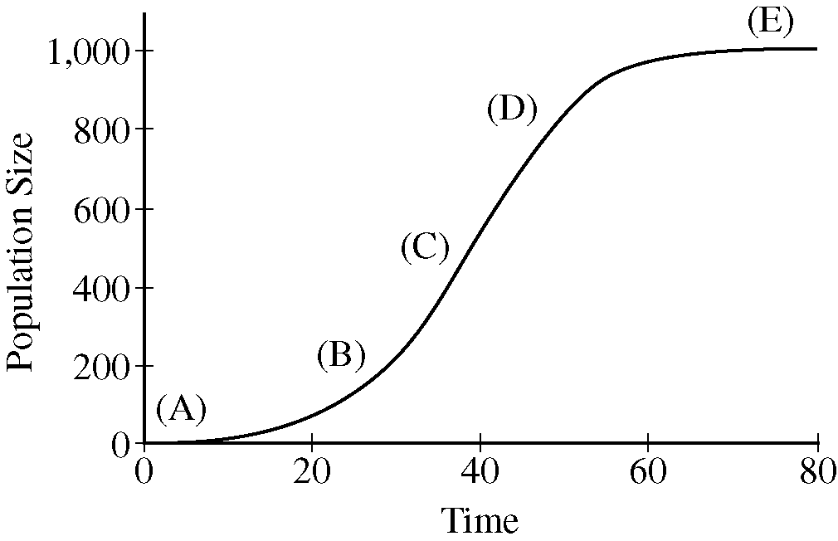

6. At which point on the graph is population growth the highest?

(a) A

(b) B

(c) C

(d) D

7. Net primary productivity in terrestrial ecosystems increases with proximity to the tropical latitudes. The best explanation for this phenomenon is that

(a) the tropics have a greater availability of newly weathered inorganic nutrient.

(b) the higher species diversity in the tropics stimulates photosynthesis.

(c) metabolic processes in tropical plant species are more energy efficient.

(d) the availability of water and stable, warm temperatures supports photosynthesis.

8. Keystone species are thought to have a profound effect on the structure and composition of ecological communities because they

(a) maintain populations of other species and overall biodiversity in the ecosystem.

(b) are more abundant than most other species in their communities.

(c) reduce diversity by competing for food resources and territory with other species.

(d) provide the foundation for all food webs.

9. On Earth, carbon cycling is most dependent upon

(a) rainforest vegetation.

(b) primary productivity in oceans.

(c) dead organic matter in soils.

(d) the atmosphere.

10. Which type of cell must die before it becomes a functional part of the plant?

(a) Guard cell

(b) Phloem sieve tube cell

(c) Mesophyll cell

(d) Xylem vessel cell

11. Which of the following statements, regarding mitochondria and chloroplasts, is correct?

(a) Plants have chloroplasts but no mitochondria while animals have mitochondria but no chloroplasts.

(b) Plants have both mitochondria and chloroplasts and animals and fungi have mitochondria but no chloroplasts.

(c) Plants and fungi have chloroplasts and mitochondria and animals have only mitochondria.

(d) Plants have chloroplasts but no mitochondria while fungi have chloroplasts and no mitochondria.

12. Mycorrhizal fungi are beneficial to the growth of many plants because they

(a) provide carbon to plants in exchange for nitrogen.

(b) protect plant roots from dehydration in drought conditions.

(c) increase the rate of photosynthesis.

(d) fix atmospheric nitrogen which can then be accessed by plants from the soil.

13. The process by which pioneering species colonise bare earth is known as

(a) primary succession.

(b) secondary succession.

(c) mass germination.

(d) ecological dispersal.

14. Which of the following metabolic pathways is common in both aerobic and anaerobic respiration?

(a) Glycolysis

(b) Chemiosmosis

(c) Oxidative phosphorylation

(d) Krebs cycle

15. Whilst completing a vegetation survey in the Jarrah forest, an ecologist notices that she is being followed by a number of splendid fairy wrens. As she continues on her transect, the wrens swoop the ground in her wake, similar to cattle egret following livestock. This behaviour is a type of

(a) opportunistic feeding.

(b) commensalism.

(c) symbiosis.

(d) predation.

Question 16 relates to the graph below.

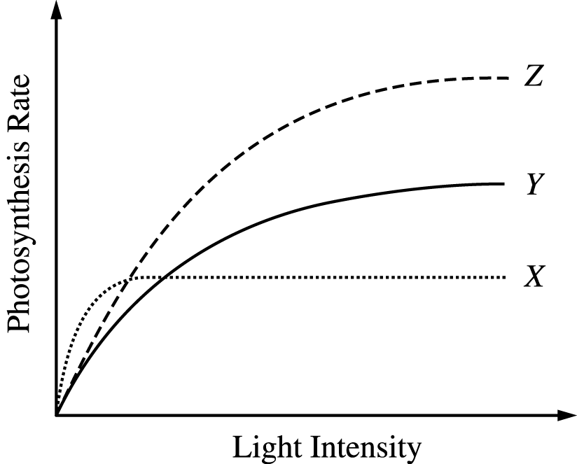

16. The graph shows the rate of photosynthesis, in response to light intensity, for three different species occupying the same niche. Based on the data for plants X, Y and Z, which of the following statements is most likely true?

(a) Species Y should outcompete species Z in all light environments.

(b) Removal of species X will allow the number of species Z to increase.

(c) Species X will outcompete the other species when placed in the shade.

(d) Species Y has the largest leaves of the three species.

17. In Western Australia, the clearing of native vegetation for agricultural development has directly resulted in an increase in the incidence of

(a) evolution.

(b) biodiversity.

(c) salinity.

(d) carbon sequestering.

18. A biology class was asked to design an experiment to test the effect of pH on the activity of a particular enzyme. The controlled variables in this experiment would only include

(a) pH, size of test tubes, reaction time.

(b) amount of enzyme, temperature, substrate concentration.

(c) substrate concentration, pH, amount of enzyme.

(d) reaction time, temperature, pH.

19. In ecological succession, a climax community can be best described as

(a) stable and more diverse.

(b) unstable and more diverse.

(c) unstable and less diverse.

(d) stable and less diverse.

20. Which of the following descriptions reflects the chemical composition of a cell membrane?

(a) Cell membranes are composed of protein bilayers punctuated by carbohydrates and lipids.

(b) Equal numbers of protein, carbohydrate and phospholipid molecules comprise the cell membrane.

(c) The cell membrane is composed of one layer of phospholipids and one layer of proteins.

(d) Phospholipids form a bilayer interspersed with proteins and carbohydrates.

21. Biodiversity hotspots are regions around the world identified as having a high

(a) degree of endemic species.

(b) level of biodiversity in a small area.

(c) rate of extinction.

(d) degree of endangered species.

The following diagram refers to question 22 and 23.

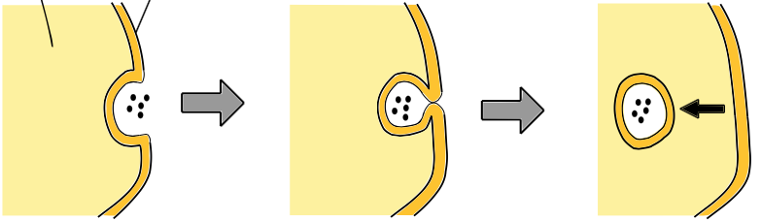

22. Which of the following statements **correctly** describes the cellular process that is taking place in the above diagram? Substances are

(a) being transported into the cell through protein channels.

(b) engulfed by a vesicle which crosses the cell membrane.

(c) engulfed by the cell membrane and then carried into the cell by a vesicle.

(d) engulfed by the cell membrane which forms a transport channel into the cell.

23. This method of transport is an example of

(a) active transport.

(b) osmosis.

(c) facilitated diffusion.

(d) passive transport.

24. A CSIRO scientist has developed a herbicide that specifically targets the chloroplasts within the Arum Lily. The active chemical in the herbicide damages the thylakoid membranes, thereby affecting photosynthetic processes.

Which of the following will be most directly affected by application of this herbicide?

(a) Absorption of light energy by chlorophyll.

(b) Synthesis of ATP.

(c) Splitting of water.

(d) The flow of electrons from photosystem I to photosystem II.

The diagram below relates to question 25 and 26.

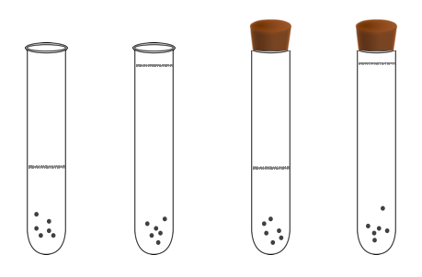

(d)

(c)

(b)

(a)

25. Obligate anaerobic bacteria will only grow and reproduce in oxygen-free conditions.

Which of the test tubes above will most likely support the growth of a thriving anaerobic bacterial colony?

(a) a

(b) b

(c) c

(d) d

26. The independent variable for this experiment on anaerobic bacterial growth is most likely the

(a) species of bacteria.

(b) bacterial growth.

(c) placement of tube stopper.

(d) availability of oxygen.

27. Which of the following statements is **incorrect**?

*Habitat fragmentation has a negative impact on the biodiversity of an ecosystem by*…

(a) reducing the carrying capacity of an ecosystem.

(b) enhancing edge effects.

(c) increasing access to resources in adjacent habitats.

(d) reducing the amount of suitable habitat for organisms.

Question 28 refers to the following diagram.

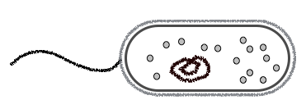

28. Classification of the cell in the diagram above would place it in which Kingdom?

(a) Animalia

(b) Protista

(c) Fungi

(d) Eubacteria

29. In the ‘lock and key’ model of enzyme function, the ‘lock’ and ‘key’ refer to the

(a) enzyme and substrate.

(b) substrate and active site.

(c) active site and enzyme.

(d) active site and enzyme-substrate complex.

30. The most common elements that are the basis of biochemical reactions in all organisms include

(a) carbon, oxygen, hydrogen and phosphorus.

(b) hydrogen, oxygen, carbon and nitrogen.

(c) hydrogen, nitrogen, carbon and sulphur.

(d) oxygen, nitrogen, potassium and sodium.

END OF SECTION ONE

**Section Two: Short Answer 50% (100 marks)**

This section has **five (5)** questions. Answer **all** questions. Write your answers in the spaces provided in this Question/Answer booklet. Wherever possible, confine your answers to the line spaces provided. Use a blue or black pen for this section. Only graphs and diagrams may be drawn in pencil.

Additional working space pages at the end of this Question/Answer booklet are for planning or continuing an answer. If you use these pages, indicate at the original answer, the page number it is planned/continued on and write the question number being planned/continued on the additional working space page.

Suggested working time: 90 minutes.

**Question 31 (20 marks)**

A group of biology students were conducting an experiment to determine the effect of different concentrations of carbon dioxide on the rate of photosynthesis. The rate of photosynthesis was determined by measuring the amount of oxygen (O2) produced. Cuttings from an aquatic plant were submerged in different concentrations of a sodium hydrogen carbonate (NaHCO3) solution. This solution provided the CO2 required for photosynthesis. A diagram of the experimental set-up is shown below.

Treatment 3

Treatment 2

Treatment 1

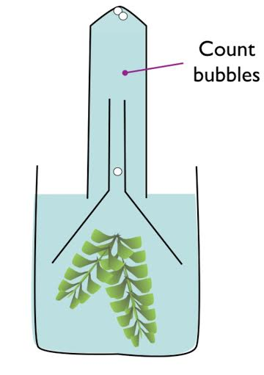

O2 bubbles produced rise to top of tubes

O2 bubbles produced rise to top of tubes

O2 bubbles produced rise to top of tubes

Aquatic plant cutting

(5 grams)

Aquatic plant cutting

(5 grams)

Aquatic plant cutting

(5 grams)

10% NaHCO3

1% NaHCO3

5% NaHCO3

The experiment was run over two hours. The test beakers were placed in a temperature controlled room and exposed to the same light source. The students used three trials for each NaHCO3 concentration tested. The number of bubbles produced were counted and recorded every 10 minutes, for the entire two hours.

(a) Identify an appropriate hypothesis for this experiment. (2 marks)

(b) Identify the following variables for this experiment.

(i) Independent (1 mark)

(ii) Dependent (1 mark)

(c) Both temperature and light intensity were controlled during this experiment. Explain the importance of these controls in terms of their effect on photosynthesis. (4 marks)

After two hours the students gathered the following results.

**Table 1**: Photosynthetic rate in an aquatic plant in response to different concentrations of CO2.

|  |  |  |  |  |  |  |  |  |  |  |  |  |  |  |
| --- | --- | --- | --- | --- | --- | --- | --- | --- | --- | --- | --- | --- | --- | --- |
| **Treatment** | Average number of bubbles produced at time intervals (mins) | | | | | | | | | | | | | |
| **0** | **10** | **20** | **30** | **40** | **50** | **60** | **70** | **80** | **90** | **100** | **110** | **120** | **Total** |
| **1** | 0 | 24 | 30 | 28 | 32 | 34 | 36 | 39 | 38 | 42 | 40 | 43 | 41 | *427* |
| **2** | 0 | 45 | 47 | 51 | 49 | 49 | 55 | 57 | 56 | 57 | 60 | 58 | 60 | *644* |
| **3** | 0 | 62 | 66 | 68 | 79 | 90 | 98 | 80 | 72 | 67 | 65 | 58 | 50 | *855* |

(d) Construct an appropriate graph for the data in **Table 1** to compare the rate of photosynthesis for different CO2 (% of NaHCO3) treatments over time. (6 marks)



(e) Describe the major patterns shown in your graph. (4 marks)

(f) Suggest how this experiment could be changed to compare the rate of photosynthesis in the following environmental conditions; (2 marks)

(i) Tropical:

(ii) Sub-arctic:

**Question 32 (20 marks)**

Vascular plants contain specialised structures in order to obtain and transport necessary molecules for metabolic reactions.

(a) Describe the function of the root system in the acquisition of the following materials:

(i) Water (3 marks)

(ii) Minerals (3 marks)

The following images represent xylem and phloem tissue from a plant stem.

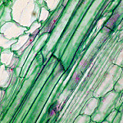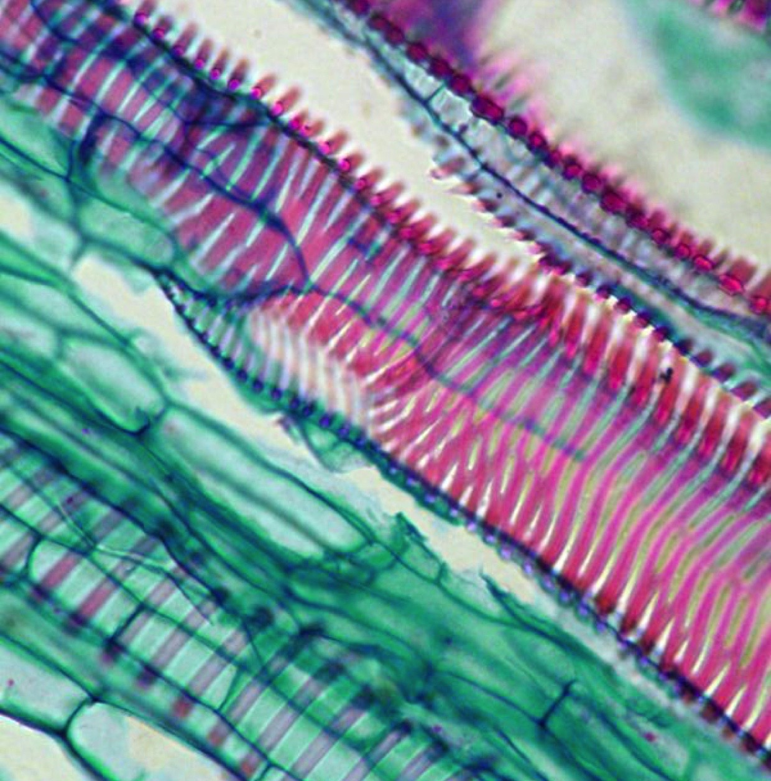

(b) Identify the main structural differences of these two tissue types that enable scientists to distinguish between them.

(i) Xylem (4 marks)

(ii) Phloem (4 marks)

The xylem and phloem have different functions within a plant.

(c) Explain the processes by which materials are transported around a plant in each type of vascular tissue. *Use a diagram to illustrate your response if necessary.*

(i) Xylem tissue (3 marks)

(ii) Phloem tissue (3 marks)

**Question 33 (20 marks)**

Mechanisms of gas exchange between animal phyla are diverse. The environment, which an animal inhabits, determines the structure and function of its respiratory system.

(a) Identify the structures used in gas exchange in the following animals: (4 marks)

**Fish**

**Mammal**

**Frog**

**Insect**

(b) Suggest **two (2)** common features present in the gas exchange surfaces of the animals listed above and explain why they are essential. (4 marks)

(c) In the space provided below, construct a simple, labelled diagram of the gas exchange surface of a mammal. The diagram must include the movement of gas over the surface and its destination. (4 marks)

(d) Compare the mechanism of gas exchange between a mammal and a fish, in relation to the environment in which they live. (4 marks)

Climate change is causing a change in the concentrations of gases in the atmosphere and the ocean. While our oceans provide around 70% of the world’s oxygen requirements, the concentration of dissolved oxygen in the water is steadily decreasing.

(e) Identify **two (2)** causes of oxygen depletion in the ocean. (2 marks)

(f) Explain how a reduction in dissolved oxygen could affect fish populations in the world’s oceans. (2 marks)

**Question 34 (20 marks)**

Like plants, water, gases and nutrients must be transported around the bodies of animals.

(a) Identify **two (2)** similarities in the transport systems of plants and animals. (2 marks)

Transporting materials around animals is the main function of the circulatory system. Circulatory fluids carry all the essential molecules around the body.

(b) Animals have either an open circulatory system or a closed circulatory system. Describe the difference between these two systems, using examples to support your answer.

(6 marks)

(c) Outline **two (2)** benefits of having a closed circulatory system. (2 marks)

(d) In the table underneath the diagram, name the structures labelled A – H of the mammal heart below. (4 marks)

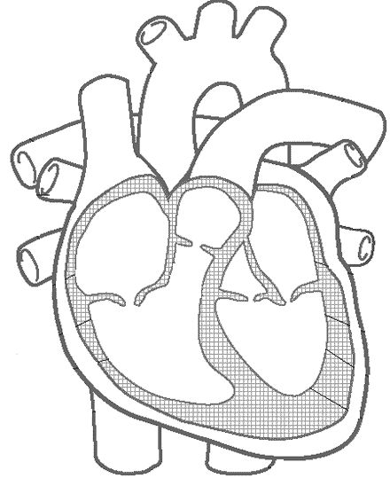

**G**

**H**

**F**

**A**

**B**

**E**

**C**

**D**

|  |  |
| --- | --- |
| **A** |  |
| **B** |  |
| **C** |  |
| **D** |  |
| **E** |  |
| **F** |  |
| **G** |  |
| **H** |  |

(e) Explain the purpose of the thickened heart tissue surrounding structure ‘E’. (2 marks)

(f) Amphibians and reptiles have a slightly different heart structure than mammals: the structure labelled ‘C’ on the above diagram is reduced or absent. Describe the effect that this anomaly has on circulation in an amphibian. (2 marks)

(g) Consider the mechanism by which amphibians exchange gas to explain how they might overcome any negative effects due to their different circulatory structures. (2 marks)

**Question 35 (20 marks)**

Ecosystems are dynamic, complex and comprised of organisms that interact with each other on many different levels. These interactions or relationships are usually based on the need for food and are associated with many structural and behavioural adaptations.

One of the major factors affecting organisms within ecosystems is competition.

(a) Explain why competition occurs within ecosystems. (2 marks)

(b) Describe how organisms living in the same ecosystem can reduce competition. Use a specific example to support your response. (3 marks)

(c) Define the term ‘*competitive exclusion principle’*. (2 marks)

(d) Identify how an organism may ‘override’ the competitive exclusion principle. (1 mark)

The relationships that exist between organisms in a food web can be essential to their ongoing survival. Symbiosis is the term used to describe the interaction between two or more species in which one or more of the species may benefit. There are three major types of symbiosis.

|  |  |  |  |
| --- | --- | --- | --- |
| **Type of Symbiosis** | **Definition** | **Example** | **Adaptation** |
|  |  |  |  |
|  |  |  |  |
|  |  |  |  |

(e) Complete the table below for the **three (3)** types of symbiosis. Identify and define each type, give a specific example and identify any adaptations that enable this symbiotic relationship to exist.

(12 marks)

END OF SECTION TWO

**Section Three: Extended Answer 20% (40 marks)**

This section contains **four (4)** questions.

Questions 36 and 37 are from Unit 1. Questions 38 and 39 are from Unit 2. Answer **one (1)** question from Unit 1 and **one (1)** question from Unit 2.

Use black or blue pen for this section. Only graphs and diagrams may be drawn in pencil. Responses can include: labelled diagrams with explanatory notes; lists of points with linking sentences; labelled tables and/or graphs; and/or annotated flow diagrams with introductory notes.

Additional working space pages at the end of this Question/Answer booklet are for planning or continuing an answer. If you use these pages, indicate at the original answer, the page number it is planned/continued on and write the question number being planned/continued on the additional working space page.

Suggested working time: 50 minutes

**Unit 1**

Choose either Question 36 or Question 37.

**Question 36 (20 marks)**

Australian terrestrial ecosystems have evolved to maximise their success in a wide range of environmental conditions. Ancient practices, human intervention and climate change have all had a significant effect on ecosystem diversity, health and stability.

(a) Describe the positive and negative impacts of low intensity fire regimes on ecosystem processes. (10 marks)

(b) *“Urbanisation provides ready-made laboratories for studying adaptive processes. Examining the influence of humans on flora and fauna overrides any negative effects of urban development.”* (Hunter, P., 2007).

Explain the validity of this quote while listing the current methods in ecosystem conservation designed to combat habitat destruction and degradation. (10 marks)

**Question 37 (20 marks)**

The west coast of Australia is a well-known migratory route for many whale species, including Blue whales, Southern-right whales and Humpback whales. They make the long journey from Antarctic waters to warm, tropical seas to give birth and then return along the same route with their newborn calves.

While direct negative impacts, like whaling, have been minimised over the last century, whale populations are still in jeopardy due to indirect human impacts.

(a) Identify **three (3)** human activities that affect the marine environment and explain how these activities have had a negative impact on whale populations. Outline the techniques used by marine ecologists to monitor whale populations under threat.

(10 marks)

Climate change can be defined as “*a change in global or regional climate patterns, attributed largely to the increased levels of atmospheric carbon dioxide produced by the use of fossil fuels”.* Climate change has had a profound effect on the world’s oceans, disrupting major currents, increasing surface water temperatures, decreasing pH and increasing sea levels.

(b) Explain how changes to the abiotic factors in our oceans, as a result of climate change, have affected ecosystem dynamics and biodiversity. Use an example/s to illustrate your response. (10 marks)

**Question Number**

**Unit 2**

Choose either Question 38 or Question 39.

**Question 38 (20 marks)**

Eukaryotic cells are enclosed by an intricate matrix of molecules. This membrane controls the movement of substances into and out of the cell.

(a) Describe the fluid mosaic model of the cell membrane and explain how materials can cross the membrane, based on their composition, size and concentration. (10 marks)

Energy is essential for life. The utilisation of energy occurs in all cells and involves the input and output of complex biological molecules.

(b) Outline the evolutionary connection between cellular respiration and ancient prokaryotic cells. Explain the process of cellular respiration in eukaryotic cells. (10 marks)

**Question 39 (20 marks)**

Every chemical reaction that occurs within every living organism is controlled by enzymatic action. The acquisition of molecules for metabolic processes would not be possible in the absence of enzymes.

(a) Explain the action of enzymes in biochemical reactions, with reference to the ‘lock and key’ model and the ‘induced fit’ model, and identify the factors that can limit their function. (10 marks)

(b) Describe the process by which animals obtain nutrients for cellular respiration. Identify the relationship between structure and function, in herbivores and carnivores, for this process. (10 marks)

END OF EXAM

**Question Number**

**Additional working space**

Question number:

**Additional working space**

Question number:

**Additional working space**

Question number:

**Question 31 (d)**



**Acknowledgements**

**Question 22 and 23**

Cell process image

Own work, CC0, https://commons.wikimedia.org/w/index.php?curid=40217073

**Question 25**

Test tube image

Clipart Panda

<http://www.clipartpanda.com/clipart_images/test-tube-clip-art-viewing-33978516>

**Question 28**

Cell diagram

By author

**Question 31**

Aquatic plants in beakers

Diagram courtesy of Dr Peter Scott

IB Biology Higher Level, (eBook, 2013)

**Question 32**

Xylem and Phloem of *Cucurbita maxima*

By (biophotos)

Flickr

**Question 34 (d)**

Unlabelled heart diagram

<http://clipart-library.com/images/BiarbL7jT.jpg>

Other diagrams or images within this exam are by the author.